The Book to the Hebrews has so far demonstrated supremacy of Jesus Christ to everything – whether it be the angels, Moses, Joshua or the earthly high priests. It has then gone on to show Jesus as our Heavenly High Priest, sitting at the right hand of God.

The aim so far has been to show Jesus is all that we need to fully worship God.

READ Hebrews 9

Now the writer turns his attention to compare the old and new covenants and does so by describing the earthly tabernacle and its furnishings.

It should be remembered that the earthly tabernacle described in Exodus 25-27, was commanded by God, but only for an earthly service.

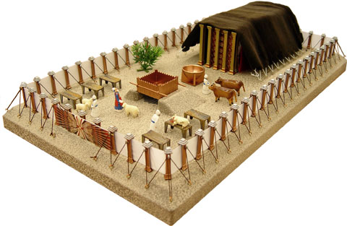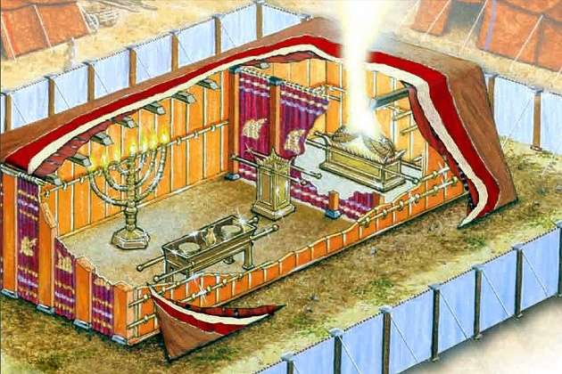

The tabernacle itself It was a tent, divided into two rooms; the first and larger part was called the Holy Place, with a veil (or curtain) separating the smaller second room, which was called the Most Holy Place, or the Holy of Holies.

Within the first room were situated:
- The lampstand - Exodus 25:31-40. It had a middle stem and six branches. The size was not specified, but it was made of pure gold and provided the only light for the tabernacle.
- The table - Exodus 25:23-30. Made of acacia wood, covered with gold and on it was placed twelve loaves bread, known as the bread of the Presence, each one representing God’s fellowship with the twelve tribes of Israel.
- The altar of incense - Exodus 30:1-8. Made of acacia wood covered with gold.
- The ark of the covenant - Exodus 25:10-22. This gold covered chest of acacia wood stood inside the Most Holy Place and within the ark were:
  - The golden pot containing manna Exodus 16:33 – to remind Israel of God’s provision, their ungratefulness and their need for Him.
  - Aaron’s rod that budded Numbers 17:6-11 - to remind Israel of their rebellion against God’s authority
  - The tablets of the covenant Exodus 25:16 – to remind Israel of their failure to keep the Ten Commandments and the rest of the law.
  - On top of the ark was the mercy seat – Exodus 25:17-22. The seat served as a top for the ark of the covenant and had cherubim above it.
  - It was onto this seat that the sacrificial blood was sprinkled on the Day of Atonement, for the forgiveness of Israel’s sin Exodus 25:17-22.

When God looked down into the ark, He saw the symbols of Israel’s sin, rebellion and failure. But when the blood of sacrifice was applied to the mercy seat, God saw that blood covering over the sin of Israel and forgave the sin.

Important though these things were, the writer doesn’t want to dwell on them. As he goes on to say, although God required them, they were only preparatory to what was important.
The writer reminds his readers, who would have been very well acquainted with the practices of the daily offerings, that the old covenant required the priests to enter the first section of the tabernacle to perform their appointed duties - tending the lampstand / replacing the bread.

But the writer also says, but into the second (part) only the high priest goes and but once a year, on the Day of Atonement. On that day his entrance before God was not for fellowship, but to atone – first with blood for his own sins and then for the sins of his people that were committed in ignorance. Any sin that was known about should have been atoned for by the person concerned.

In this respect, Jesus’ work is far greater than the work done on the Day of Atonement. Jesus’ work on the cross is sufficient to atone for both the sins we do in ignorance and sins that we know about.

Access into the Holiest Place was, therefore, severely restricted and Rabbis recorded that the priest who entered ‘did not prolong his prayer in the Holy of Holies on the Day of Atonement, because it might make the people think he had been killed. When he came out, he threw a party for all his friends, because he had emerged safely from the presence of God’.

We can see from these verses that the Most Holy Place was not a place open to anyone and even when the High Priest did enter it was under strict guidelines. Yet, the writer tells us it is the Holy Spirit who gives understanding regarding the priestly service under the Old Covenant.

The Holy Spirit has always been present in the outworking of God’s plans, yet His role changed after Pentecost. Prior to that, His ministry seems to have been on the basis of being sent to specific places, at specific times and to specific people. After Pentecost, the Holy Spirit permanently came to the group of believers and is available to anyone today who calls on Jesus as their Saviour.

When Jesus’ died on the cross, we are told the veil of the temple was torn in two from top to bottom Matthew 27:51 – it was in this act that the old passed away, to enable God’s new way to be revealed. From that time on, God was accessible to all, by the way of Jesus.

God remains accessible, but only through Jesus John 14:6.

We are told that the priests and high priests who were serving within the Temple were unable to make an effective atonement, because if the cleansing is incomplete for the priest, as it will be because he is a sinful human, the sacrifice offered will in turn be incomplete for the person being atoned for.

The weakness of the priestly service under the Old Covenant was its inability to change and transform the inner person, something that Jesus spoke of with Nicodemus when he talked of being born again John 3.

Again, the writer talks about superiority – this time in terms of speaks of a perfect tabernacle, one that has not been made by the hands of men. It is here that Jesus ministers, as our High Priest – in the very throne room of God, a place of perfection.

We are told that Jesus does not need to enter the Heavenly sanctuary carrying sacrificial blood. Jesus enters on His own merit - His sacrifice was and is superior to any goat or bull offering, in that it was perfect - and only a perfect sacrifice is acceptable to God to grant eternal redemption.

We are told in Revelation that a Temple will be rebuilt in Jerusalem in the future and the sacrificial system will be resumed. When that takes place, the blood of goats and bulls will remain inferior to the blood of Jesus. Those new sacrifices will be of no value.

The reason the Old Testament sacrifices could not save was because the blood was from animals. Animal blood would have been sufficient to seal a normal covenant, but God’s covenant with man to deal with sin that had been introduced into the world by men Romans 5:12, needed sinless blood as an atonement for our sin. When Jesus went to Calvary as the Lamb of God, the blood He shed was sinless, so it would satisfy the just demands of a Holy God Isaiah 53:11.

v12 tells us too, that blood secured for us an eternal redemption.

The text then mentions the ashes of a heifer - a young cow that has yet to calf. This animal was slaughtered, burnt and its ashes kept, to be later mixed with water and that was used by the priests for ceremonial washing Numbers 19:1-10.

Ceremonial washing was ritually practiced, by many people, throughout the Bible times. For the Jews, water was a significant part of their cleansing rites - but there is no need for us, who have put our faith in Jesus, to continually be cleansed in a process that is merely external and symbolic.

The system of ceremonial cleansing adopted by the priests is no doubt the origin of ‘holy water’ used by some today, but today’s rituals are without value, being as with everything else, a shadow of the real thing. In this case, the real thing is Jesus offered us the ability to be perfectly cleansed.

There is a danger in putting any ritual or superstition in place of, or before Jesus. Scripture clearly tells us that whatever we do put in place of God is an idol and God will not tolerate such behaviour. It is certainly in His nature to be merciful and if we let such idol worship continue, we will have to answer for it at the judgement. Remember that anything can be an idol – money, property of any kind, or anything that removes your focus from God being centre of your whole life and focus.

The writer then says Jesus blood has the ability to purify our conscience from dead works to serve the living God. The conscience is the part of you that has the power to choose between right and wrong - the idea here is that when you are saved, you experience a change of heart that results in a change of lifestyle, a new life. The Old Testament sacrifices could never produce such a change, but the blood of Jesus has that power to put us right with God. We literally become a new creation in Jesus - we are redeemed.

So, in addition to removing the physical idols, we must also look at those attitudes that get in the way of our worship of God.

We are told there was a necessity for Jesus to die. When someone dies, their will takes effect and hopefully their living wishes, generally in terms of their money and property, are taken care of by the executor. In our case, it was Jesus who died for the new covenant to take effect and His will is recorded in the Bible. Spurgeon said, ‘…if Jesus did not die, then the gospel is null and void.’ Friends and relatives may gain from an earthly will, but it is God’s family of believers who gain from Jesus’ Heavenly will.

Having explained the workings of the Heavenly sanctuary, the writer says there is a need for a perfect sacrifice to exist in that perfect sanctuary.

It was acceptable for the copies of the heavenly things in the earthly sanctuary to be ‘purified’ with imperfect sacrifices, but the heavenly things themselves could only be purified with a perfect offering.

Jesus’ sacrifice was made on earth, but it was that earthly sacrifice which allows Him to continue His Heavenly work for us as our mediator and High Priest. His ministry continues in interceding for us and in defending us against Satan Revelation 12:10. Intercession is ongoing, but atonement for our sins was only performed once. As the text says that He should offer Himself repeatedly. Jesus’ sacrifice was once-for-all, which perfectly satisfied God’s holy justice.

The perfect sacrifice enables the promise of an eternal place in Heaven for those who accept Jesus’ blood, but equally it promises an eternal place in Hell for those who do not accept Jesus’ blood.

The writer then states …it is appointed for man to die once and after that comes judgment, so Christ (was) offered once to bear the sins of many… Just as certainly as we die once and then face judgment, so Jesus only had to die once (not repeatedly, not continually) to bear our sins.

It was probably not the intention of the writer to deal with the subject of reincarnation, but he does emphatically deny its existence here. We do not live and die, live and die, to sometime face an eternal reckoning sometime in the future. The life you live now is the only one you will have – you live it, then face judgment. This means that there are no second chances beyond the grave and ‘now’ or ‘today’ must be the time to choose for Jesus Christ, because when we die, we simply face the judgment.

Spurgeon said about this verse, ‘A man dies once, and after that everything is fixed and settled, and he answers for his doings at the judgment. One life, one death – then everything is weighed, and the result declared: ‘after this the judgment.’ So, Christ comes and dies once and after this, for Him also the result of what He has done, namely, the salvation of those who look for him. He dies once and then reaps the fixed result, according to the analogy of the human race, of which he became a member and representative.’ Spurgeon

There are obvious exceptions to this one death rule, but they are exceptions. Clearly, Scripture tells us that Enoch Genesis 5:24 and Elijah 2 Kings 2:11 did not even die at all and those who will be taken in the rapture 1 Thessalonians 4:17 will also not die.

Yet, several people in the Bible were raised from the dead 1 Kings 17:22, 2 Kings 13:20-21, Matthew 9:25, John 11:43-44. Acts 20:9-11 and ultimately, these people died twice. However, the over-riding Biblical principle is that it is appointed for man to die once.

As we can be certain of death, we can be certain that Jesus will return, He will appear a second time, not to deal with sin but to save those who are eagerly waiting for Him. The focus of Jesus’ first coming was to deal with the problem of sin through His atoning sacrifice, but now, having perfectly dealt with the sin, Jesus will return to save His people.

The chapter ends with an assumption that all believers will be eagerly waiting for Him. Are you? Unfortunately, it is sad to say that not all believers are eagerly waiting Jesus’ return.

Scripture is full of prophecy and some of it has yet to be fulfilled. In Matthew 25:1-13, Jesus told us to watch and to be ready. READ

Jesus may be ministering at the right hand of God now, but He has assured us He is returning and in many passages, including Mark 13:7-9, we are given clear indications of what to look out for.

Those things are not written to scare or concern us, they are to show that God is in control and it will be God’s timing when Jesus returns, however, in the meantime we are told to watch and in that watching and working for God, we should do it eagerly.

Jesus remains our High Priest, a certainty in a world of uncertainty. Let us wait eagerly for Him.

